**Hadoop Assignment 2.1**

Task1 .Check whether /user/acadgild directory exists or not in HDFS directory.

Sol :

**hadoop fs -ls / [Exists]**

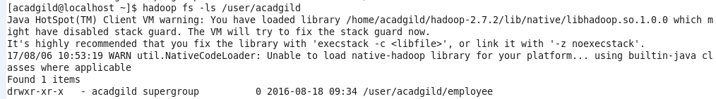

Create a directory /user/acadgild/Hadoop

**hadoop fs -mkdir /user/acadgild/Hadoop**

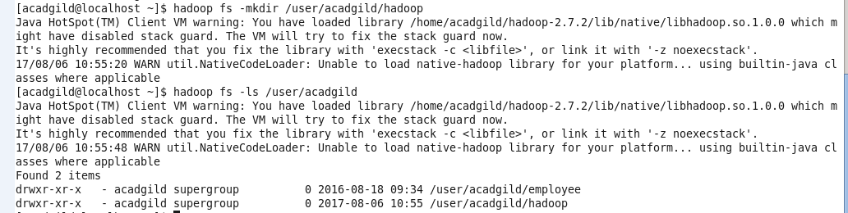

Task 2

Create a file under the directory /user/acadgild/Hadoop ,with name word-count.txt

Sol:

**hadoop fs -touchz /user/acadgild/Hadoop/word-count.txt**



**hadoop fs -appendToFile /home/acadgild/Documents/Sample.txt /user/acadgild/Hadoop/word-count.txt**



**hadoop fs -cat /user/acadgild/Hadoop/word-count.txt**



